**PROJECT DESIGN PHASE**

**-**

**1**

**PRO**

**BLEM**

**SOLUTION**

**FIT**

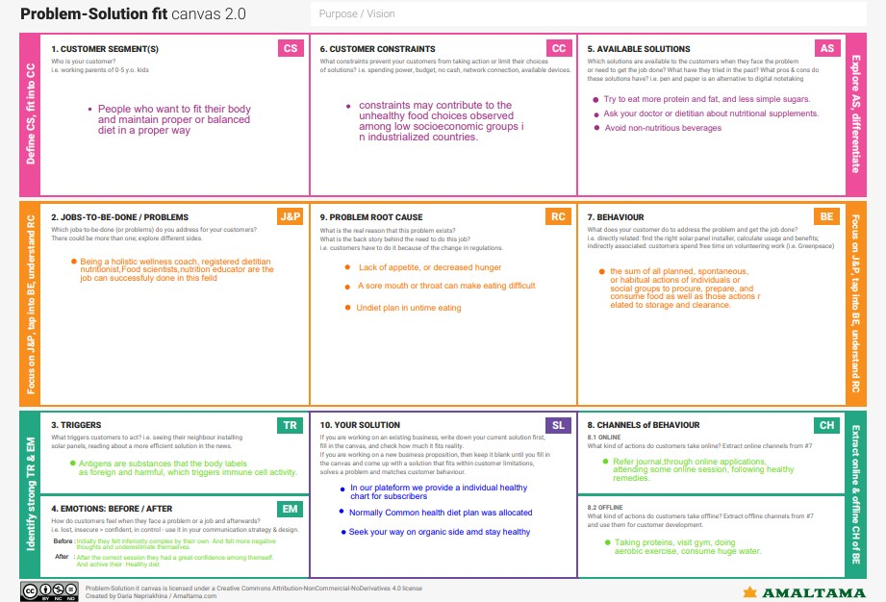

Team ID

PNT2022TMID25633

Project Name

AI Powered Nutrition Analyst for

Fitness Enthusiasts.